C/C++ PROGRAMMING - HARSHINIE M - DAY 6

1.

/*
* Purpose:
* Write a C++ program to demonstrate the working of different types of
* constructors and a destructor in a class.
* The program should illustrate:
* 1. Default Constructor
* 2. Parameterized Constructor
* 3. Copy Constructor
* 4. Destructor call sequence
*
* Author: Harshinie M
* Date : 29-12-2025
*/

#include <iostream>
using namespace std;

class Test {
public:
// Default Constructor
Test() {
cout << "Test() --> Default Ctor" << endl;
}

// Parameterized Constructor
Test(int) {
cout << "Test(int) --> Parameterized Ctor" << endl;
}

// Copy Constructor
Test(const Test &) {
cout << "Test(const Test&) --> Copy Ctor" << endl;
}

// Destructor
~Test() {
cout << "~Test() --> Destructor" << endl;
}
};

int main() {
Test objOne; // Calls Default Constructor
Test objTwo = 100; // Calls Parameterized Constructor
Test objThree = objTwo; // Calls Copy Constructor
}

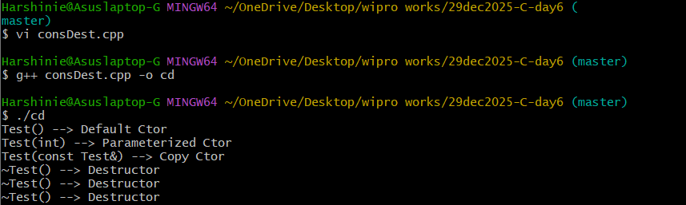

2.

/*
* Purpose:
* Write a C++ program to demonstrate the invocation of the copy constructor
* when an object is passed to a function using call by value.
* The program also shows the order of constructor and destructor calls.
*
* Author: Harshinie M
* Date : 29-12-2025
*/

#include <iostream>
using namespace std;

class Test {
public:
// Default Constructor
Test() {
cout << "Test() --> Default Ctor" << endl;
}

// Parameterized Constructor
Test(int) {
cout << "Test(int) --> Parameterized Ctor" << endl;
}

// Copy Constructor
Test(const Test &) {
cout << "Test(const Test&) --> Copy Ctor" << endl;
}

// Destructor
~Test() {
cout << "~Test() --> Destructor" << endl;
}
};

// Function demonstrating call by value
Test fun(Test arg) {
return arg;
}

int main() {
Test objTwo = 100; // Calls Parameterized Constructor
fun(objTwo); // Copy Constructor is invoked
}

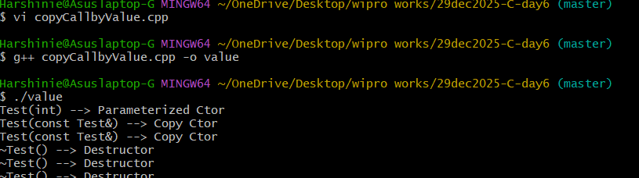

3.

/*
* Purpose:
* Write a C++ program to demonstrate passing an object to a function
* using call by reference and to show that the copy constructor
* is NOT invoked in this case.
*
* Author: Harshinie M
* Date : 29-12-2025
*/

#include <iostream>
using namespace std;

class Test {
public:
// Default Constructor
Test() {
cout << "Test() --> Default Ctor" << endl;
}

// Parameterized Constructor
Test(int) {
cout << "Test(int) --> Parameterized Ctor" << endl;
}

// Copy Constructor
Test(const Test &) {
cout << "Test(const Test&) --> Copy Ctor" << endl;
}

// Destructor
~Test() {
cout << "~Test() --> Destructor" << endl;
}
};

// Function demonstrating call by reference
Test& fun(Test& arg) {
return arg;
}

int main() {
Test objTwo = 100; // Calls Parameterized Constructor
fun(objTwo); // No Copy Constructor call
}
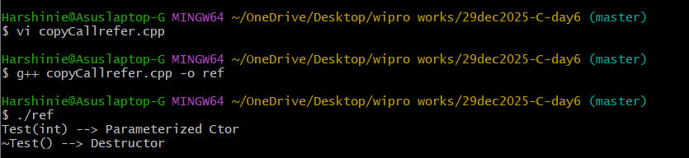

4.

/*
* Purpose:
* Write a C++ program to demonstrate the use of a friend function
* to access private members of a class. The program shows that
* the main() function can access a class’s private constructor
* and private member functions when declared as a friend.
*
* Author: Harshinie M
* Date : 29-12-2025
*/

#include <iostream>
using namespace std;

class Test { // All members of a class are private by default
int data;

// Private constructor with default argument
Test(int x = 10) : data(x) {
cout << "constructor called" << endl;
}

// Private member function
void disp() {
cout << "Data: " << data << endl;
}

// Granting access to main()
friend int main();
};

int main() {
Test obj = 100; // Accessing private constructor
obj.disp(); // Accessing private member function
}

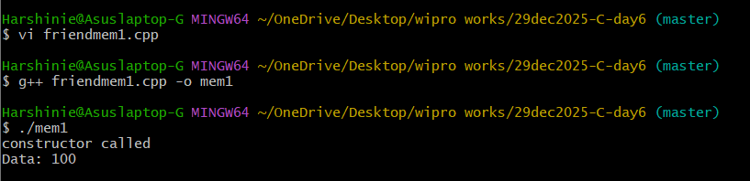

5.

/*
* Purpose:
* Write a C++ program to demonstrate the use of a friend function
* to access private data members of a class.
* The program shows how a non-member function can access
* private members when declared as a friend.
*
* Author: Harshinie M
* Date : 29-12-2025
*/

#include <iostream>
using namespace std;

class Box {
int length; // private data member

public:
// Parameterized constructor with default value
Box(int len = 10) : length(len) {}

// Friend function declaration
friend void showLength(Box &b);
};

// Friend function definition
void showLength(Box &b) {
cout << "Length : " << b.length << endl;
}

int main() {
Box gift; // Object created using default argument
showLength(gift); // Friend function accessing private data
}

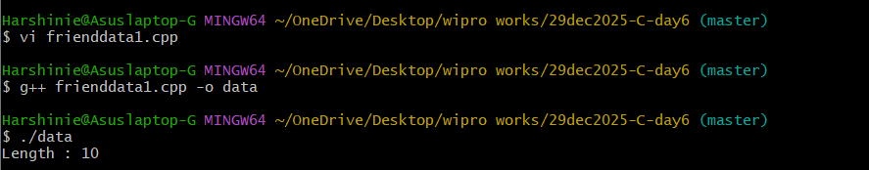

6.

/*
* Purpose:
* Write a C++ program to demonstrate the use of a friend class
* to access private members (private constructor and private
* member function) of another class.
*
* Author: Harshinie M
* Date : 29-12-2025
*/

#include <iostream>
using namespace std;

class Test { // All members of a class are private by default
int data;

// Private constructor
Test(int x = 10) : data(x) {
cout << "constructor called" << endl;
}

// Private member function
void disp() {
cout << "Data: " << data << endl;
}

// Declaring friend class
friend class UsingTest;
};

class UsingTest {
Test obj;

public:
// Constructor accessing Test's private constructor
UsingTest(int x = 100) : obj(Test(x)) {}

// Member function accessing Test's private function
void print() {
obj.disp();
}
};

int main() {
UsingTest obj = 100;
obj.print();
}

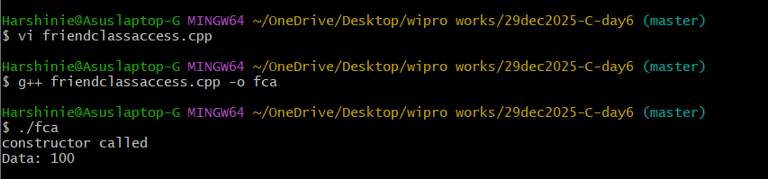

7.

/*
* Purpose:
* Write a C++ program to demonstrate single inheritance
* with public inheritance. The program shows that public
* member functions of a base class can be accessed using
* a derived class object.
*
* Author: Harshinie M
* Date : 29-12-2025
*/

#include <iostream>
using namespace std;

class Base {
public:
void funOne() {
cout << "Base::funOne()" << endl;
}

void funTwo() {
cout << "Base::funTwo()" << endl;
}
};

// Derived class publicly inheriting Base
class Derived : public Base {};

int main() {
Derived dObj; // Derived class object
dObj.funOne(); // Accessing Base class function
dObj.funTwo(); // Accessing Base class function
}

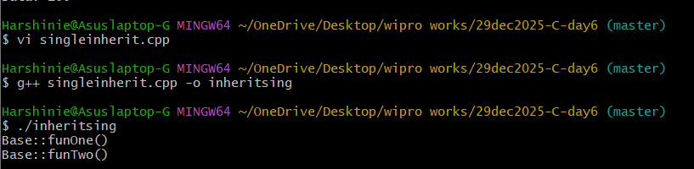

8.

/*
* Purpose:
* Demonstrate class abstraction, constructors, and copy constructor
* using an array-based class in C++.
*
* Author: Harshinie M
* Date : 29-12-2025
*/

#include <iostream>
using namespace std;

class MyArray { // abstraction
int arr[100];
int size;

public:
MyArray();
MyArray(int data);
MyArray(const MyArray&);
void printArray();
MyArray& extend(MyArray&);
};

int main() {
MyArray objOne;
MyArray objTwo(100);
MyArray objThree = objTwo;

objOne.printArray();
objTwo.printArray();
objThree.printArray();

// objFour = objTwo.extend(objThree);
// objFour.printArray();
}

MyArray::MyArray() {
size = 100;
for (int cnt = 0; cnt < size; cnt++)
arr[cnt] = 0;
}

MyArray::MyArray(int data) {
size = 100;
for (int cnt = 0; cnt < size; cnt++)
arr[cnt] = data + cnt;
}

MyArray::MyArray(const MyArray& rhsObj) {
size = rhsObj.size;
for (int cnt = 0; cnt < size; cnt++)
arr[cnt] = rhsObj.arr[cnt];
}

void MyArray::printArray() {
cout << "Size: " << size << "\tarray:" << endl;
for (int cnt = 0; cnt < size; cnt++)
cout << arr[cnt] << " ";
cout << endl;
}

MyArray& MyArray::extend(MyArray& rhsObject) {
// Future implementation using dynamic memory
return rhsObject;
}

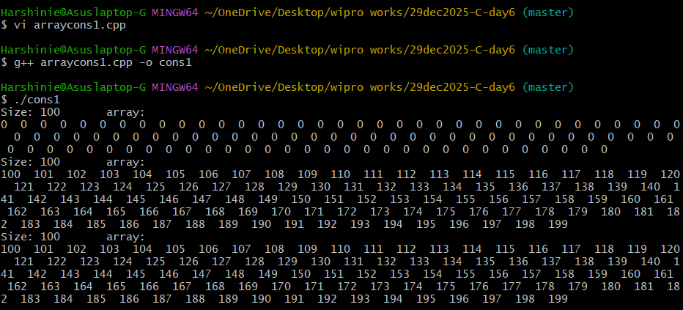

9.

/*
* Purpose:
* Demonstrate array abstraction, constructors, copy constructor,
* and object extension using a class in C++.
*
* Author: Harshinie M
* Date : 29-12-2025
*/

#include <iostream>
using namespace std;

class MyArray { // abstraction
static const int max = 100;
int arr[max];
int size;

public:
MyArray(); // size = 10
MyArray(int data); // size = 20
MyArray(const MyArray&); // copy constructor
void printArray();
MyArray extend(MyArray&); // extend two arrays
};

int main() {
MyArray objOne;
MyArray objTwo(100);
MyArray objThree = objTwo; // copy constructor called

objOne.printArray();
objTwo.printArray();
objThree.printArray();

MyArray objFour = objOne.extend(objThree);
objFour.printArray();
}

MyArray::MyArray() {
size = 10;
for (int cnt = 0; cnt < size; cnt++)
arr[cnt] = 0;
}

MyArray::MyArray(int data) {
size = 20;
for (int cnt = 0; cnt < size; cnt++)
arr[cnt] = data + cnt;
}

MyArray::MyArray(const MyArray& rhsObj) {
size = rhsObj.size;
for (int cnt = 0; cnt < size; cnt++)
arr[cnt] = rhsObj.arr[cnt];
}

void MyArray::printArray() {
cout << "Size: " << size << "\tarray:" << endl;
for (int cnt = 0; cnt < size; cnt++)
cout << arr[cnt] << " ";
cout << endl;
}

MyArray MyArray::extend(MyArray& rhsObj) {
MyArray newObj;
newObj.size = size + rhsObj.size;

for (int cnt = 0; cnt < size; cnt++)
newObj.arr[cnt] = arr[cnt];

for (int nCnt = 0, cnt = size; cnt < newObj.size; cnt++)
newObj.arr[cnt] = rhsObj.arr[nCnt++];

return newObj;
}

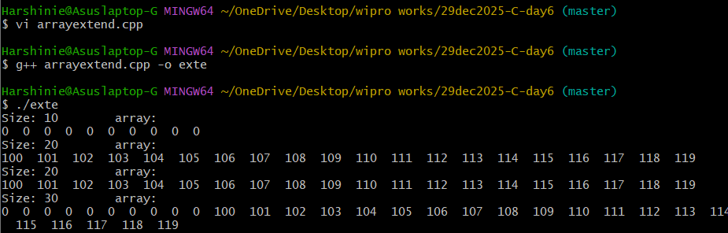

10.

/*
* Purpose:
* Demonstrate object copying in a class using an array in C++.
*
* Author: Harshinie M
* Date : 29-12-2025
*/

#include <iostream>
using namespace std;

class MyArray { // abstraction
int arr[100]; // array
int size; // integer

public:
MyArray();
MyArray(int data);
void printArray();
};

int main() {
MyArray objTwo(100); // parameterized constructor
MyArray objThree = objTwo; // object copying

objTwo.printArray();
objThree.printArray();
}

MyArray::MyArray() {
size = 100;
for (int cnt = 0; cnt < size; cnt++)
arr[cnt] = 0;
}

MyArray::MyArray(int data) {
size = 100;
for (int cnt = 0; cnt < size; cnt++)
arr[cnt] = data + cnt;
}

void MyArray::printArray() {
cout << "Size: " << size << "\tarray:" << endl;
for (int cnt = 0; cnt < size; cnt++)
cout << arr[cnt] << " ";
cout << endl;
}

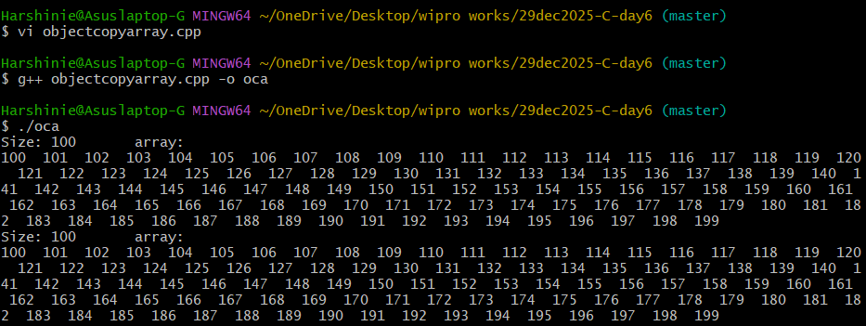

11.

/*
* Purpose:
* Demonstrate deep copy using copy constructor
* to avoid dangling pointer issues in C++.
*
* Author: Harshinie M
* Date : 29-12-2025
*/

#include <iostream>
using namespace std;

// Code demonstrates deep copy to avoid dangling pointer
class MyArray {
int *arr;
int size;

public:
MyArray();
MyArray(int data);
MyArray(const MyArray&);
void printArray();

~MyArray() {
if (size) {
delete[] arr;
}
size = 0;
}
};

int main() {
MyArray objTwo(100); // parameterized constructor
objTwo.printArray();

{
MyArray objThree = objTwo; // copy constructor (deep copy)
objThree.printArray();
} // objThree destroyed here

objTwo.printArray(); // safe access, no dangling pointer
}

MyArray::MyArray(const MyArray& rhs) {
size = rhs.size;
arr = new int[size]; // separate memory allocation
for (int cnt = 0; cnt < size; cnt++)
arr[cnt] = rhs.arr[cnt];
}

MyArray::MyArray() : size(10) {
arr = new int[size];
for (int cnt = 0; cnt < size; cnt++)
arr[cnt] = 0;
}

MyArray::MyArray(int sz) : size(sz) {
int data = 101;
arr = new int[size];
for (int cnt = 0; cnt < size; cnt++)
arr[cnt] = data + cnt;
}

void MyArray::printArray() {
cout << "Size: " << size << "\tarray:" << endl;
for (int cnt = 0; cnt < size; cnt++)
cout << arr[cnt] << " ";
cout << endl;
}

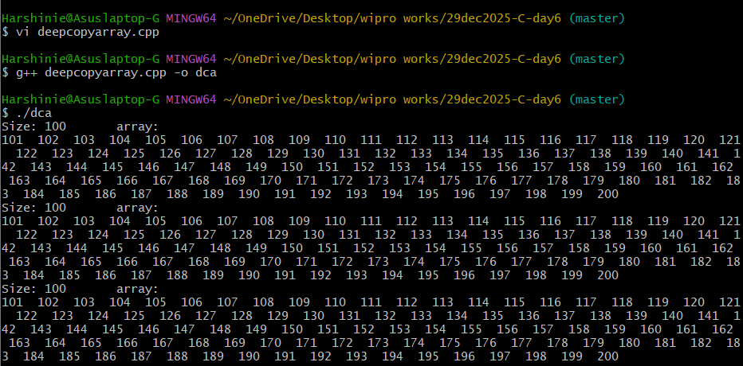

12.

/*
* Purpose:
* Demonstrate static data member and static member function in C++.
*
* Author: Harshinie M
* Date : 29-12-2025
*/

#include <iostream>
using namespace std;

class Employee {
static string compName; // static data member

public:
static string company() { // static member function
return compName;
}
};

int main() {
cout << "Employee::company() --> " << Employee::company() << endl;

Employee obj1;
cout << "obj1.company() --> " << obj1.company() << endl;
}

// Static data member definition
string Employee::compName = "Wipro Ltd";

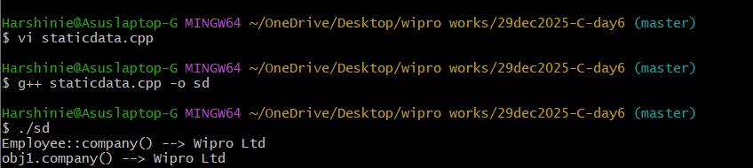

13.

/*
* Purpose:
* Demonstrate Singleton design pattern in C++ using static member
* to ensure only one object is created.
*
* Author: Harshinie M
* Date : 29-12-2025
*/

#include <iostream>
using namespace std;

class Singleton {
private:
static Singleton *ptr2Obj;

// Private constructors
Singleton() {
cout << "Object created..." << endl;
}
Singleton(int x) {
cout << "Object created...with " << x << endl;
}
Singleton(const Singleton &);

public:
// Static method to get single instance
static Singleton& getSingleton() {
if (ptr2Obj == nullptr)
ptr2Obj = new Singleton();
return *ptr2Obj;
}

void disp() {
cout << "Singleton::disp()" << endl;
}
};

// Initialize static member
Singleton* Singleton::ptr2Obj = nullptr;

int main() {
// Singleton objOne; // Error: constructor is private

Singleton &refObj = Singleton::getSingleton();
refObj.disp();
}

